# **Populations Around the World**

Group 3 Members:Marcus, Ivana, Gianna, Prabhdeep

# Project outline

Exploring population changes across different countries over the years with particular focus on the changes between the proportion of males vs. females in each population and how that is forecast to change into the future.

This information can be used for resource planning and allocation into the future particular in countries where the projected population growth rate is rapid to ensure it can be done sustainably.

# Data Sources that would help solve the problem

* Kaggle.com – Population by Age and Sex from 1950 to 2100
* <https://www.kaggle.com/ahmethoso/wpp-population-by-age-and-sex>

# Inspiring Visualisations

## Moving Bar Graph showing male vs female population.

## Male and Female Dominated Countries (by Year)

## Bar Graph Race

# Sketch of Final Design

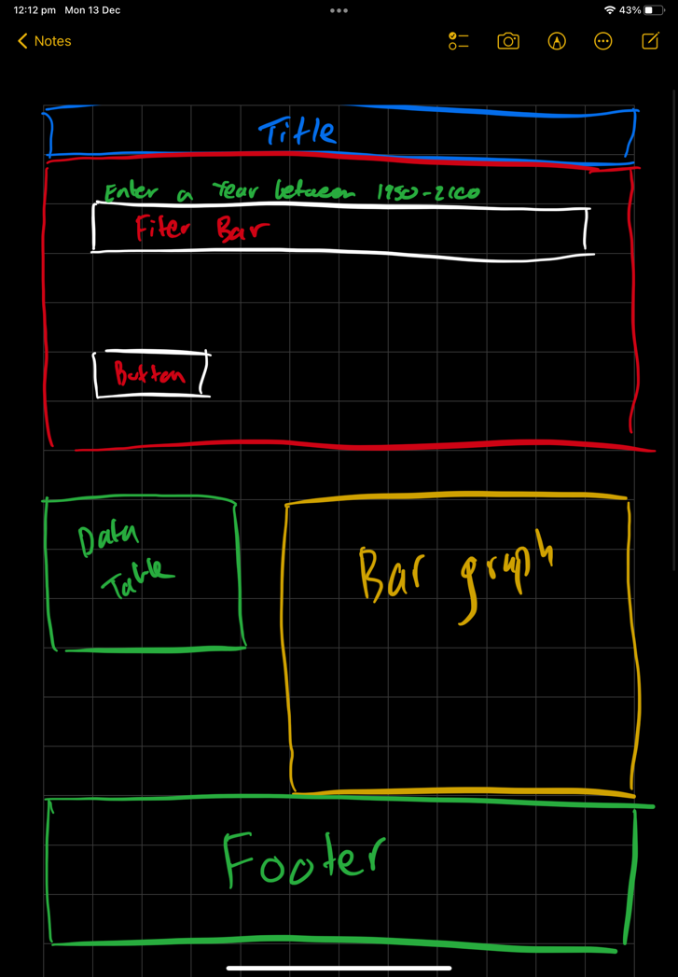

# GitHub Link

**GitHub Link:** https://github.com/MarcusKorea/project2